Resource for Natures Colours:
Words for the Song “I can sing a rainbow”

Red and yellow and pink
and green Orange and purple and blue
I can sing a rainbow
Sing a rainbow Sing a rainbow too

Listen with your eyes
Listen with your eyes
And sing everything you see
You can sing a rainbow
Sing a rainbow
Sing along with me

The sun is yellow, the grass is green
Look how the sky is blue!
We can sing a rainbow
Sing a rainbow
Surely you can too

Listen with your eyes
Listen with your eyes
And sing everything you see
You can sing a rainbow
Sing a rainbow
Sing along with me

The sky is black, the clouds are white
And it's raining too
But we can sing a rainbow
Sing a rainbow
Of happiness for you

Sample of Collage Butterfly Pictures
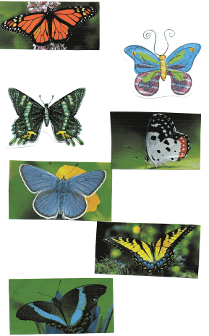

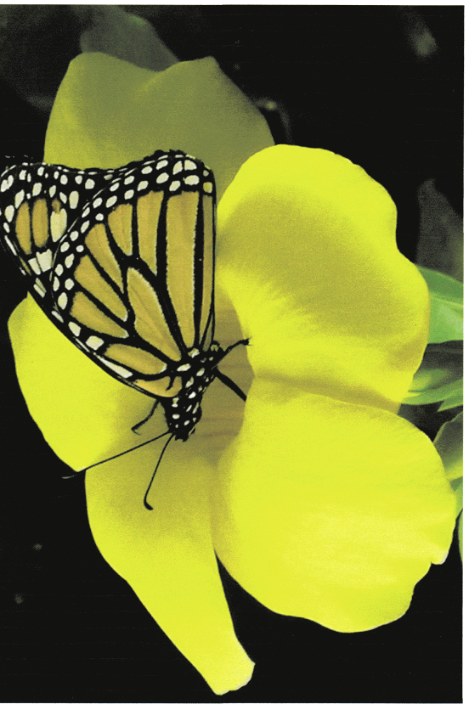

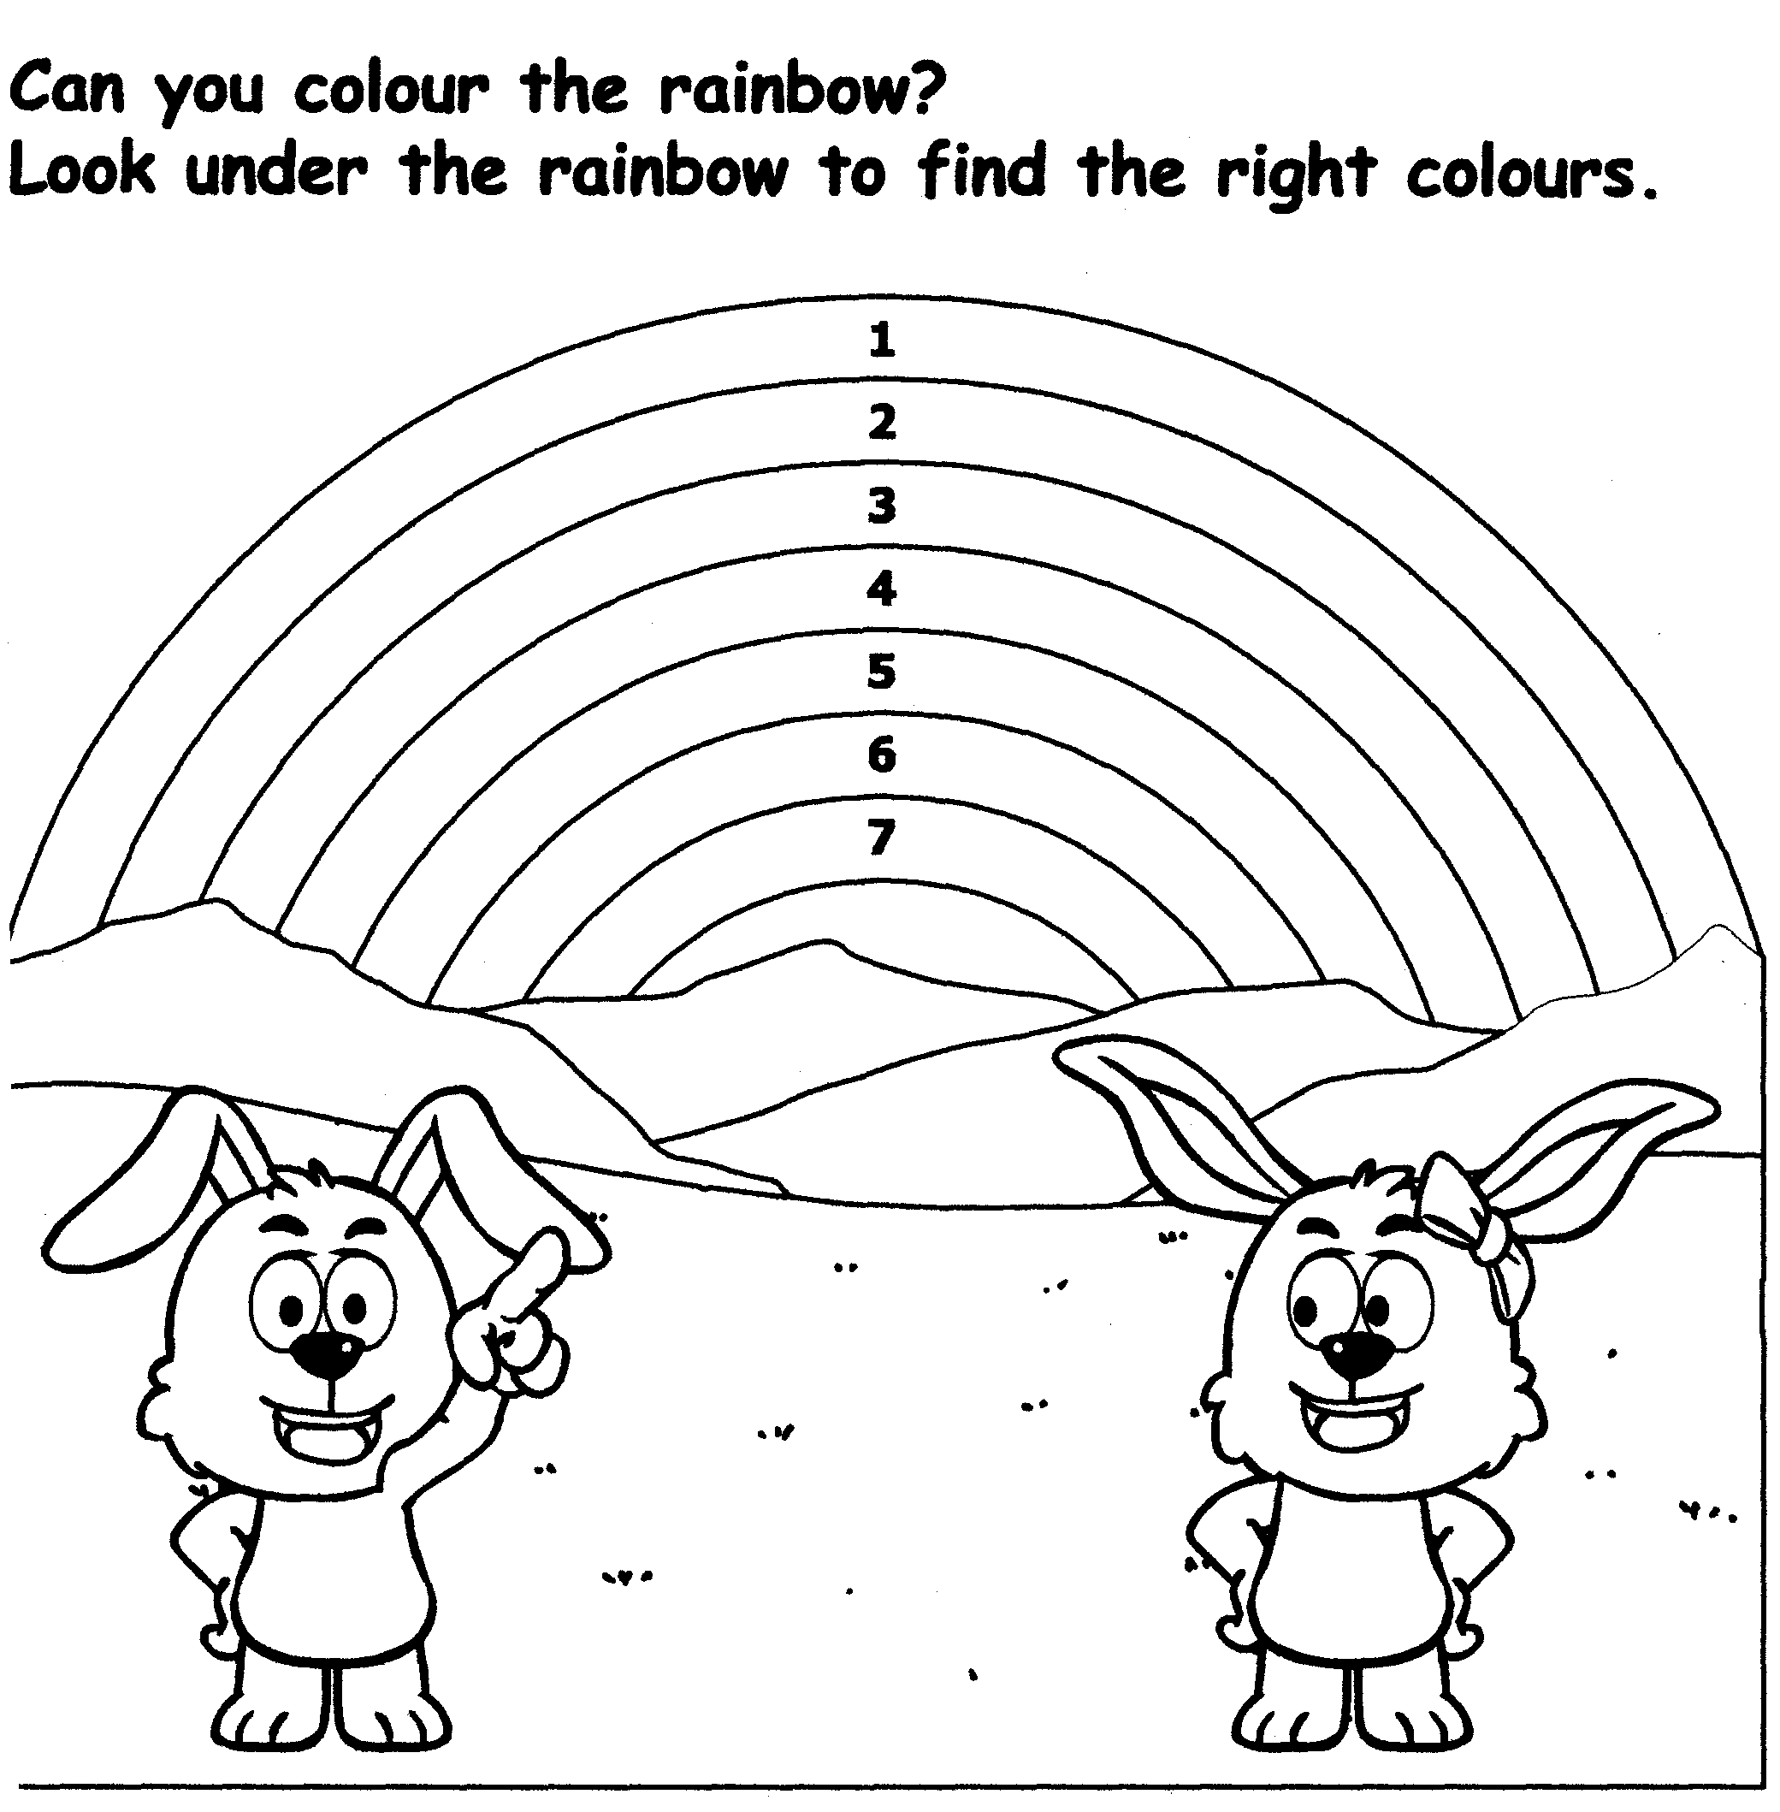

1 = Red 2 = Yellow 3 = Pink 4 = Green 5 = Orange 6 = Purple 7 = Blue

